**Apna - Yourstory**

**Google Play’s ‘Best App for Personal Growth 2020’ helps blue-collar workers find jobs**

[yourstory.com](https://yourstory.com/2020/12/google-play-best-app-personal-growth-2020-blue-collar-jobs)

Sohini Mitter

5-6 minutes

2020 has been a tough year for the job market due to pandemic-led uncertainties. Over one **million blue-collar workers** in India were left without jobs after the COVID-19 lockdown in March as **employment demand** dropped by 80 percent, as per industry estimates.

Even though industrial operations have resumed, many sectors like **ecommerce, retail, healthcare, logistics, IT-BPOs**, etc.that employ blue-collar workers in large numbers continue to face a **demand-supply mismatch.**

**Apna**, a **jobs search app** for blue-collar workers, has stepped in to fill this gap. It wants to be the **LinkedIn for bottom-of-the-pyramid** workers in India.

The app has been built by **ApnaTime Tech**, a Bengaluru-based startup inspired by Bollywood blockbuster *Gully Boy*’s #ApnaTimeAayega motto.

Apna is backed by **Lightspeed India, Sequoia Capital, Greenoaks Capital,** and **Rocketship VC**. It raised [$8 million in a Series A round](https://yourstory.com/2020/08/funding-alert-apnaco-raises-8-million-lightspeed-sequoia) in September.

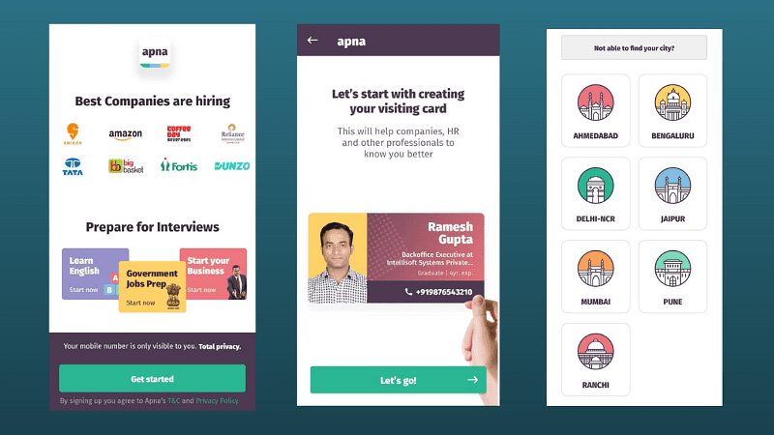

Apna connects **entry level professionals** like carpenters, electricians, welders, plumbers, packers, sales agents, delivery executives, data entry operators, security guards, ward boys, peons, clerks, cooks, nurses, and so on to future employers.

The platform is targeted at **non-English speaking** internet users, who have so far been oblivious to the world of **professional networking.**

Apna lists **10,000 active job listings** across Mumbai, Delhi-NCR, Bengaluru, Pune, Ahmedabad, Jaipur, and Ranchi. It plans to go live in more cities in 2021.

The app has **fulfilled hiring needs** of India’s top startups, including Swiggy, Amazon, Flipkart, BYJU’S, WhiteHat Jr, Toppr, Bigbasket, Dunzo, Licious, PharmEasy, MedLife, Grofers, Shadowfax, and several others.

In 2020, Apna also won Google Play’s **‘Best App for Personal Growth’** award. The app has crossed **one million downloads** and is rated 4.3 out of 5.

**Key features: discovery and community**

Users can log in with their mobile numbers followed by an **OTP verification.** The platform lists **jobs for 10th pass, 12th pass,** graduates, and post-graduates.

They can select up to **four categories** at a time, and search for jobs by **salary, location, interest,** and **skill level** (fresher, experienced, and expert).

The app’s biggest draw is the **ApnaCard** feature that lets job-seekers generate a **virtual business card** within five minutes.

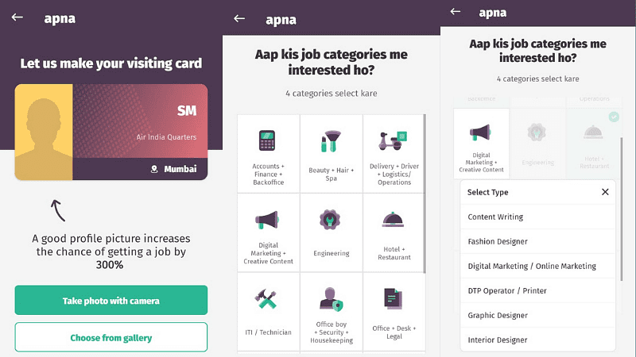

They simply have to enter details like **name, age, gender, education, skills, and location** to create their ‘public profile’. This card can be shared with potential employers during job interviews.

Job seekers have the option of **calling the employer directly** from within the app, **sharing job listings** via WhatsApp, **scheduling interviews**, and getting job alerts.

They can also watch tutorial videos on **how to apply** for a job.

The app’s social feature **ApnaGroup** allowsusers to connect to **vertical-specific communities** in accounting, admin, delivery, driving, data entry, office assistant, cooking, retail counter, and other fields.

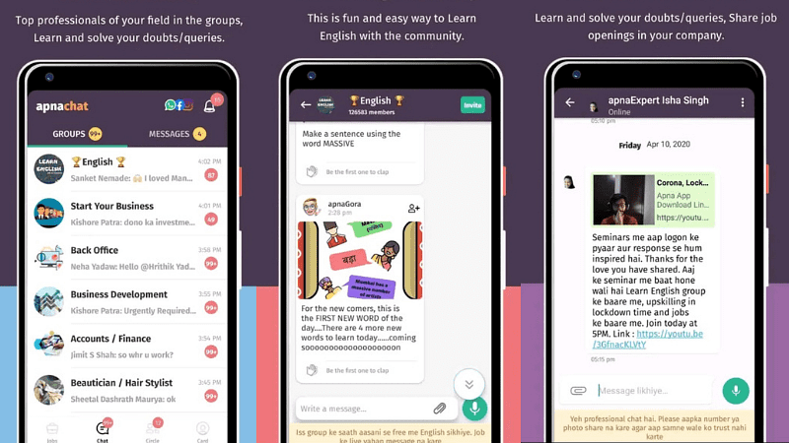

Through these communities, job seekers can **chat with top professionals** in each field, **showcase their talent,** get problem-solving tips, and stay abreast of **new job openings**. Until now, **2.7 million members** use ApnaGroup.

One of the most active communities on ApnaGroup is **Learn English**. Any user can join the group for free, **take interactive lessons**, and **upskill themselves** to suit their job requirements.

Users who have entrepreneurial ambitions can be a part of the **Start Your Business** community that shares **information on government grants,** crowdfunding, loans and benefits available to new businesses. It also lets users **scout for business partners** from within the ApnaGroup community.

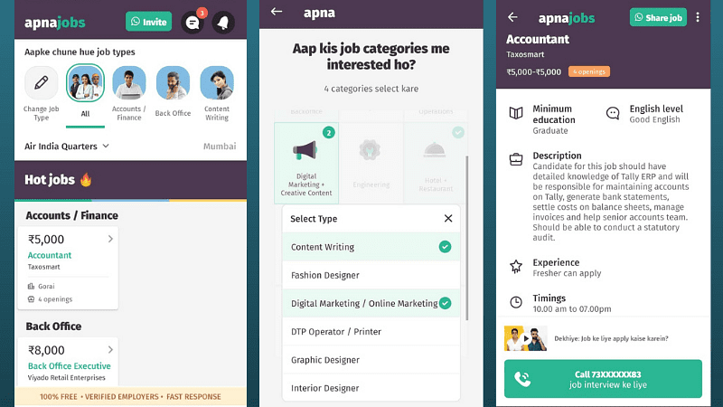

The third key feature is **ApnaCircle** that helps blue-collar workers stay connected to their friends by **syncing their phonebook** with the app. Apna believes that **8 in 10 job leads** come through friend circles.

This feature also lets users discover **relevant job openings** in companies where their friends are employed. Like on LinkedIn, they can also find out **where their friends are working** and stay updated on their job changes.

**Verdict: Can disrupt blue-collar recruitment**

Apna is just a year old, but it already looks like a **serious entrant** in the blue-collar job recruitment space that services **250 million workers**. It claims to havefacilitated over a **million job interviews** and is growing 3X month-on-month.

The app is free, **feature-rich**, **intuitive, social, and community-focused**, and has all the makings of becoming a **disruptive player** in the segment.

Apna also **prioritises privacy** and keeps the user's **mobile number hidden.** This is particularly helpful for female job seekers on the platform.

Even though the app uses **Hinglish to cater to the masses**, Apna could do with deeper **UX/UI localisation** in all the cities it is present in, and expand its **job listings** too.

Apna is making both **job discovery** and **job application** seamless. Most importantly, it is **fulfilling an important need gap** in uncertain times. It leaves little to be desired.

No wonder, Google has recognised it as one of the best apps of 2020.